# **CL-Class (C216) Coupe 2007-2014**

# Mercedes-Benz CL-Class (C216) Coupe 2007-2014 comes in 2 different available Suspension Systems. Some models come with an Air Suspension System that has Front and Rear Air Spring Bag Strut Assemblies in which the Air Spring Bag and Shock Absorber works as a unit. Other models have an ABC-Hydraulic Suspension System that has 2 Front Coil Over Struts and 2 Rear Coil Over Struts. Height Sensors tell the Control Module the vehicle’s height, allowing the Control Module to make any necessary changes and adjustments on the vehicle’s Struts or any other height sensitive components like Headlights. Here at Bavaria Center you will find many of the necessary parts and components to fix your Mercedes-Benz CL-Class (C216) Coupe 2007-2014 Suspension System for less. Your satisfaction is our guarantee!

# **1-ABC HYDRAULIC**

# **Suspension**

Mercedes-Benz CL-Class (C216) Coupe 2007-2014 ABC Hydraulic Suspension System has 2 Front & 2 Rear Coil Over Struts. Here at **Bavaria Center** you will find many of the necessary parts and components to fix your Mercedes-Benz CL-Class (C216) Coupe 2007-2014 ABC Hydraulic Suspension System for less. Your satisfaction is our guarantee!

Mercedes S-Class C216 ABC shock absorber (FL)

Active Body Control (ABC) shock absorber, front left

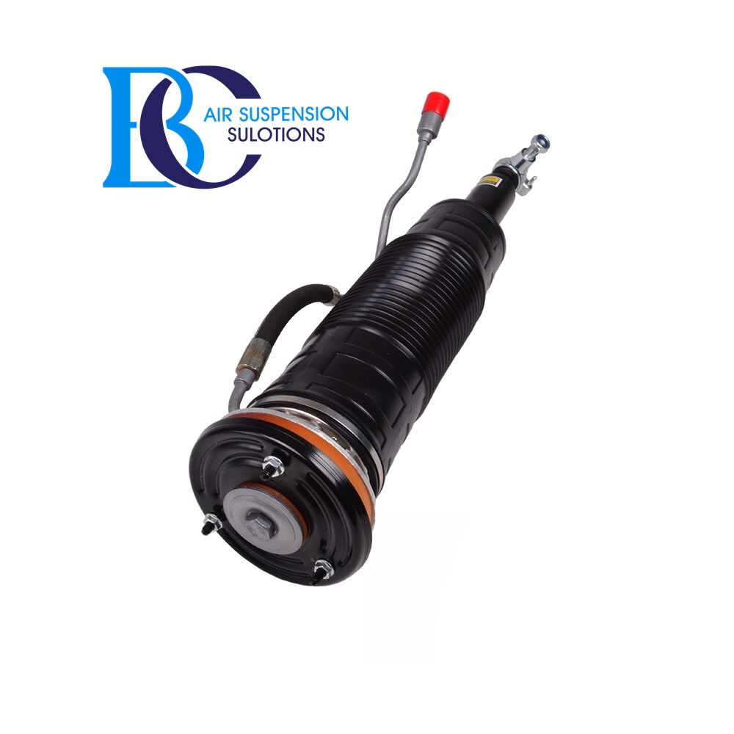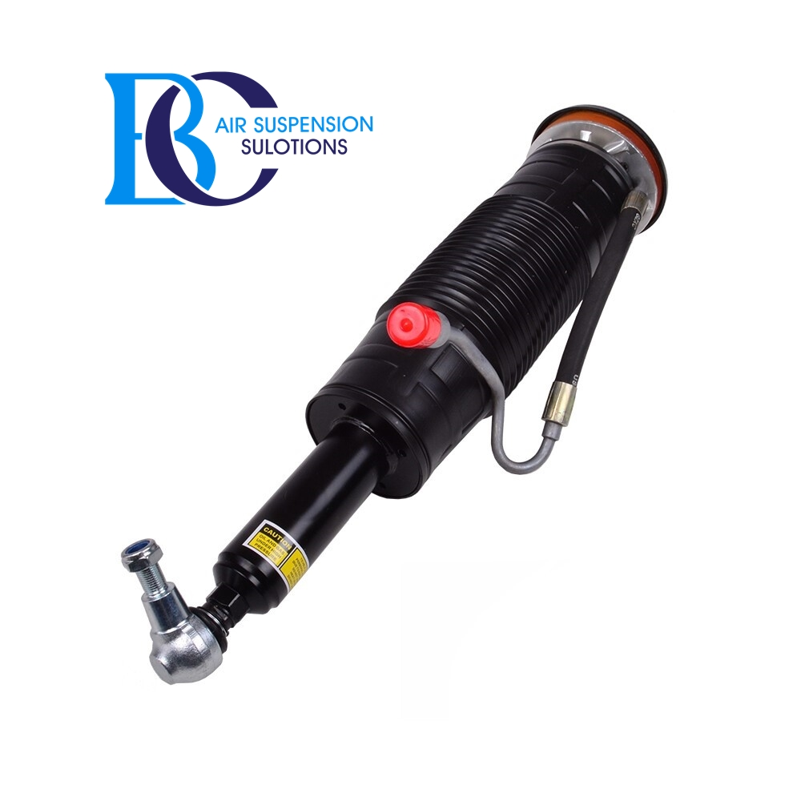

Description

This is the complete front left shock absorber (strut) for the Active Body Control (ABC) suspension of the Mercedes S-Class C216.

**Can be installed in the following vehicles:** Mercedes S-CLASS Coupe (C216) 2006-2013  
 CL 500 (216.371, 216.373)  
 CL 500 4-matic (216.386, 216.394)  
 CL 600 (216.376)

**Replaced shocks with the original spare part numbers:**

A2213207913, 2213207913,

A2213207713, 2213207713

A2213206113, 2213206113

A2213206513, 2213206513

A2213206713, 2213206713

A2213200113, 2213200113

A2213202313, 2213202313

A221320791380, 221320791380

Mercedes S-Class C216 ABC shock absorber (FR)

Active Body Control (ABC) shock absorber, front right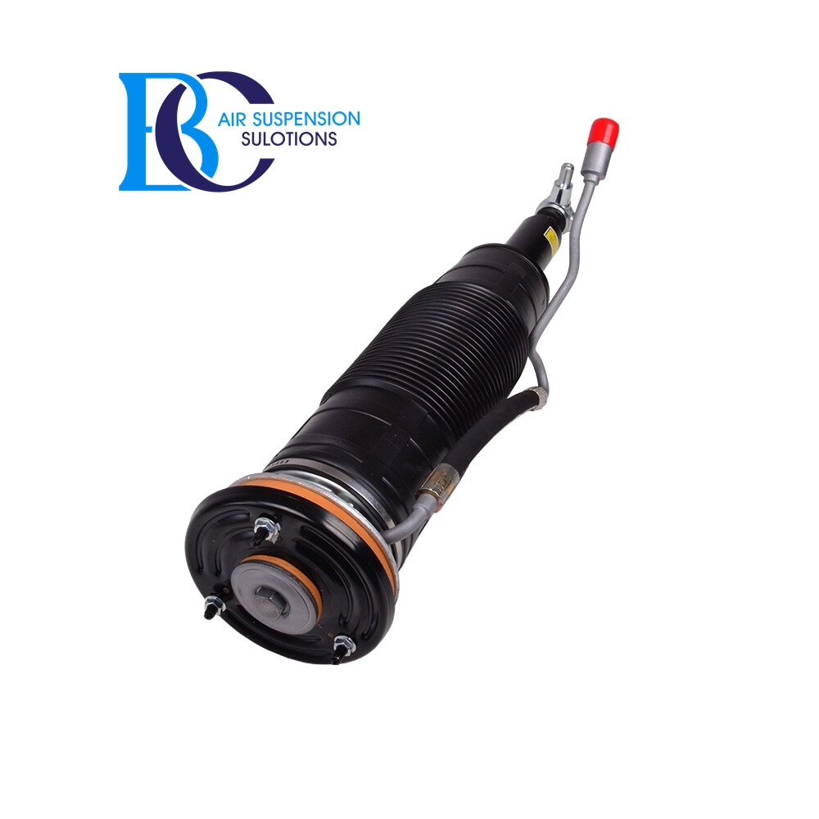

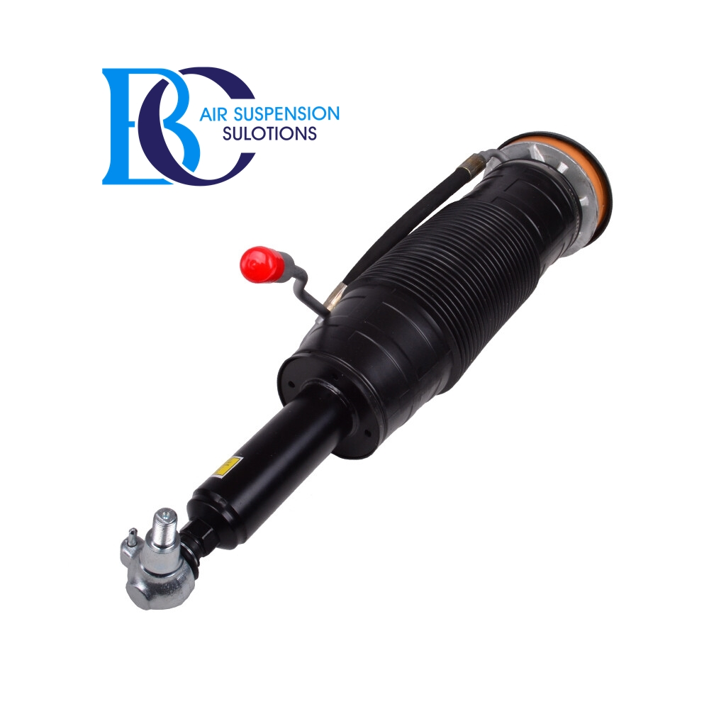

* Description

This is the complete front right shock absorber (strut) for the Active Body Control (ABC) suspension of the Mercedes S-Class C216.

**Can be installed in the following vehicles:** Mercedes S-CLASS Coupe (C216) 2006-2013  
 CL 500 (216.371, 216.373)  
 CL 500 4-matic (216.386, 216.394)  
 CL 600 (216.376)  
  
 **Replaced shocks with the original spare part numbers:** A2213208013, 2213208013  
 A2213207813, 2213207813  
 A2213206213, 2213206213  
 A2213206613, 2213206613  
 A2213206813, 2213206813  
 A2213200213, 2213200213  
 A2213202413, 2213202413  
 A221320801380, 221320801380

Mercedes S-Class C216 ABC shock absorber RL

Active Body Control (ABC) shock absorber, rear left

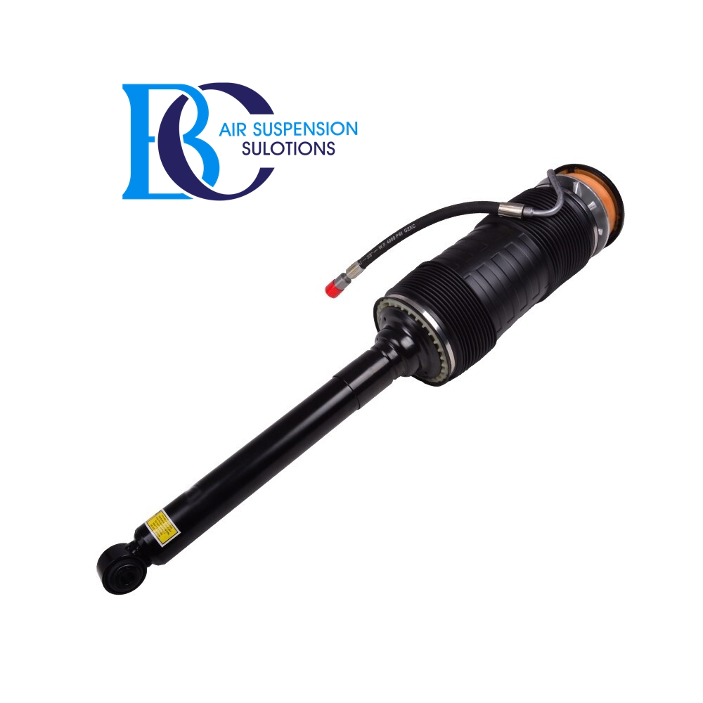

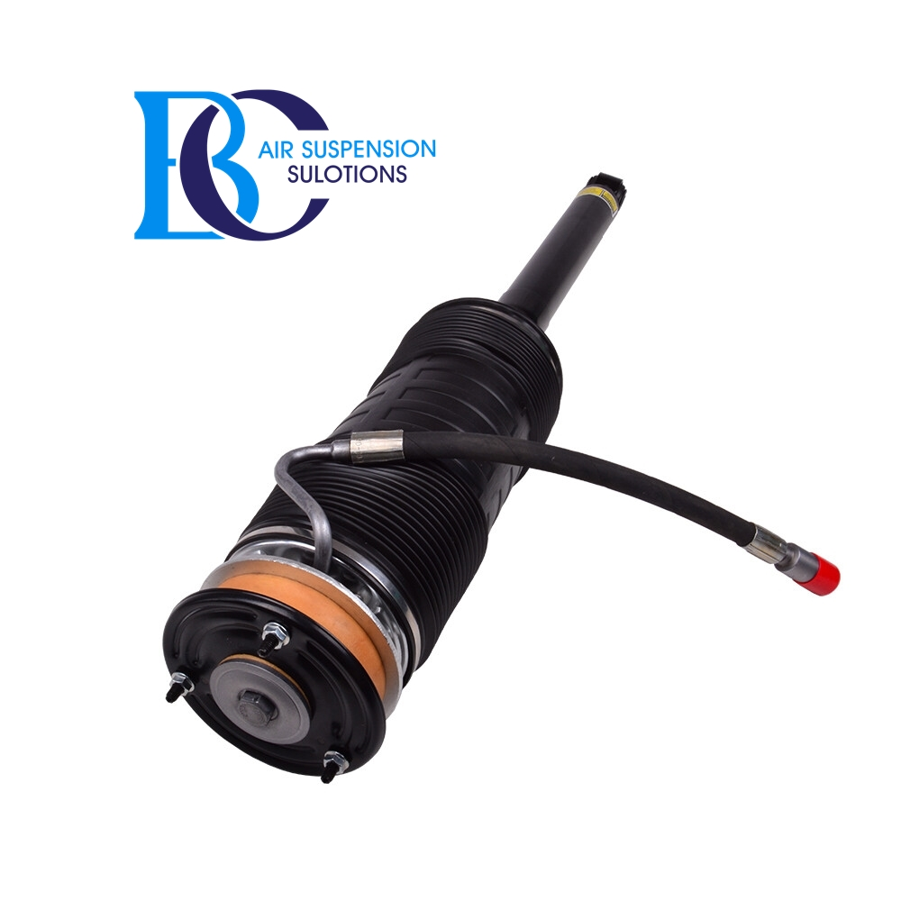Description

This is the complete rear left shock absorber (strut) for the Active Body Control (ABC) suspension of the Mercedes S-Class C216.

**Can be installed in the following vehicles:** Mercedes S-CLASS Coupe (C216) 2006-2013  
 CL 500 (216.371, 216.373)  
 CL 500 4-matic (216.386, 216.394)  
 CL 600 (216.376)  
  
 **Replaced shocks with the original spare part numbers:** A2213208913, A2213208713, A2213206313, A2213200313, A221320891380  
 2213208913, 2213208713, 2213206313, 2213200313, 221320891380

Mercedes S-Class C216 ABC shock absorber RR

Active Body Control (ABC) shock absorber, rear right

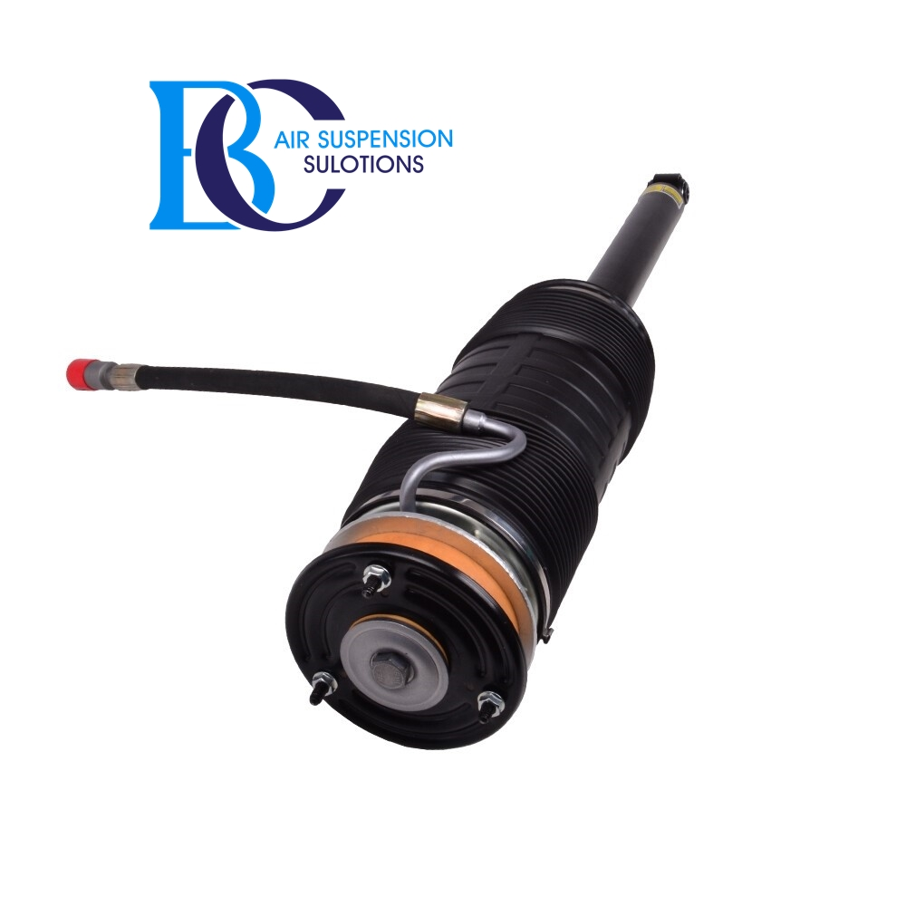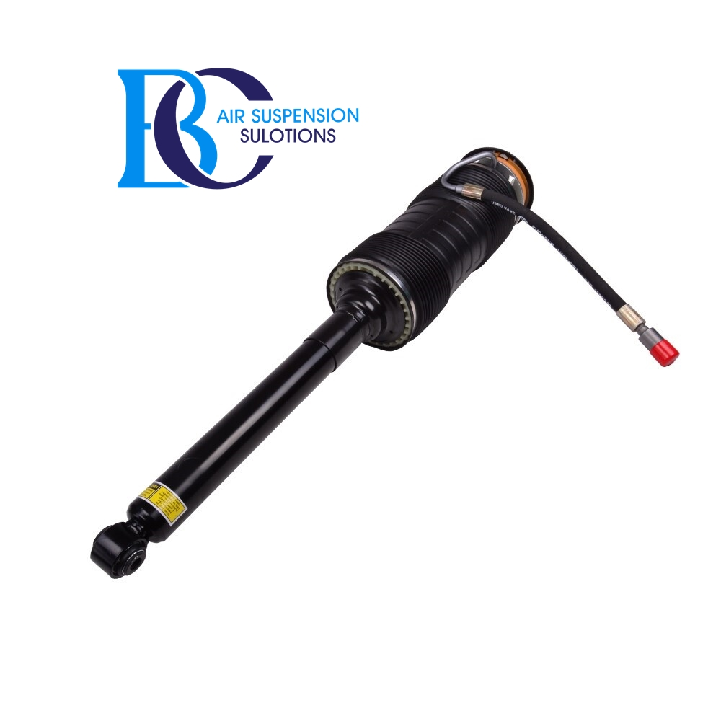Description

This is the complete rear right shock absorber (strut) for the Active Body Control (ABC) suspension of the Mercedes S-Class C216.

**Can be installed in the following vehicles:** Mercedes S-CLASS Coupe (C216) 2006-2013  
 CL 500 (216.371, 216.373)  
 CL 500 4-matic (216.386, 216.394)  
 CL 600 (216.376)  
  
 **Replaced shocks with the original spare part numbers:** A2213209013, A2213208813, A2213206413, A2213200413, A221320901380  
 2213209013, 2213208813, 2213206413, 2213200413, 221320901380

# **2- 4MATIC AWD AIRMATIC**

# **Suspension**

Mercedes-Benz CL-Class (C216) Coupe 2007-2014 4MATIC AWD AIRMATIC Air Suspension System has Front and Rear Air Spring Bag Strut Assemblies in which the Air Spring Bag and Shock Absorber works as a unit. Here at Bavaria Center you will find many of the necessary parts and components to fix your Mercedes-Benz CL-Class (C216) Coupe 2007-2014 4MATIC AWD AIRMATIC Air Suspension System for less. Your satisfaction is our guarantee!

Mercedes S C216 4MATIC AIRMATIC Air Spring Rear Suspension

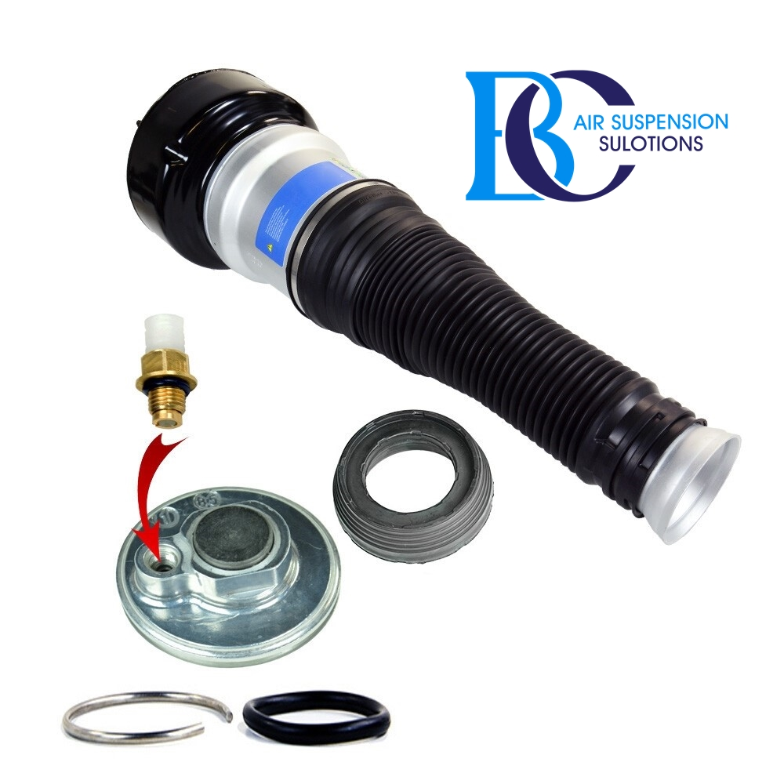

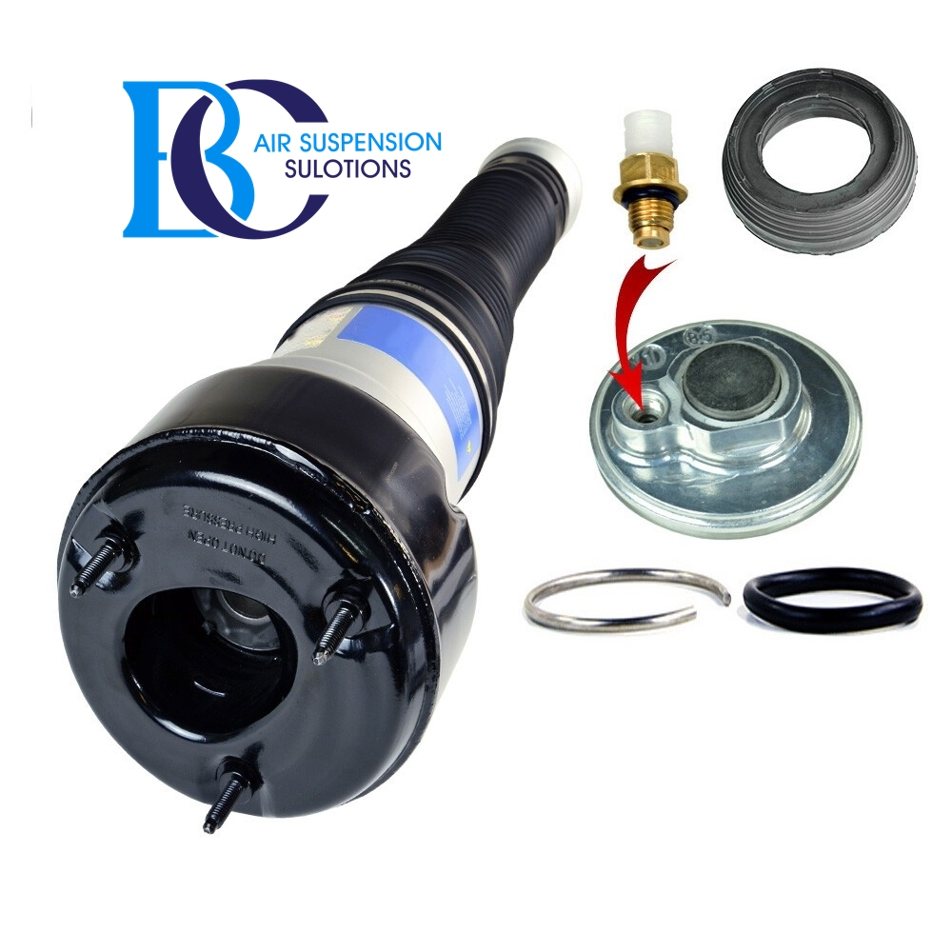Description

This is a new air spring for Rear side.

.

**Can be installed in the following vehicles:**

Mercedes CL-Class C216/W216 4Matic 2006--

.

**Original spare part numbers (shock absorbing strut):**

2213205513 ; 2213201338 ; 2213205713 ; 2213205613 ; 2213201438 ; 2213205813

[Mercedes S C216 4MATIC AIRMATIC Air Spring Front Suspension](https://www.miessler-automotive.com/Mercedes-S-C216-4MATIC-AIRMATIC-Air-Spring-Suspension-Service-Kit-REAR)

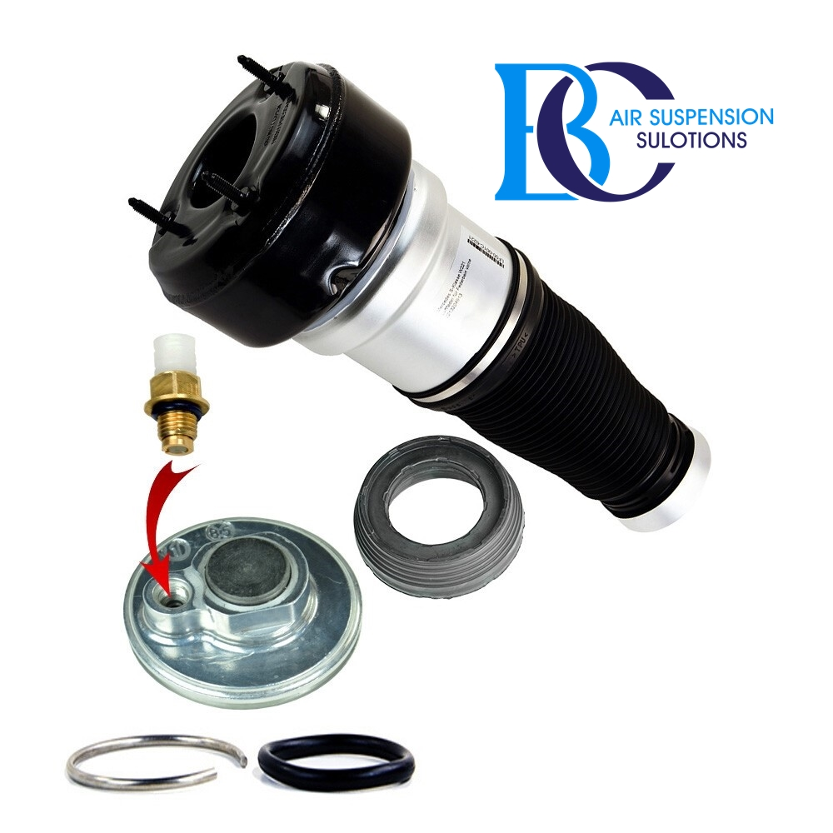

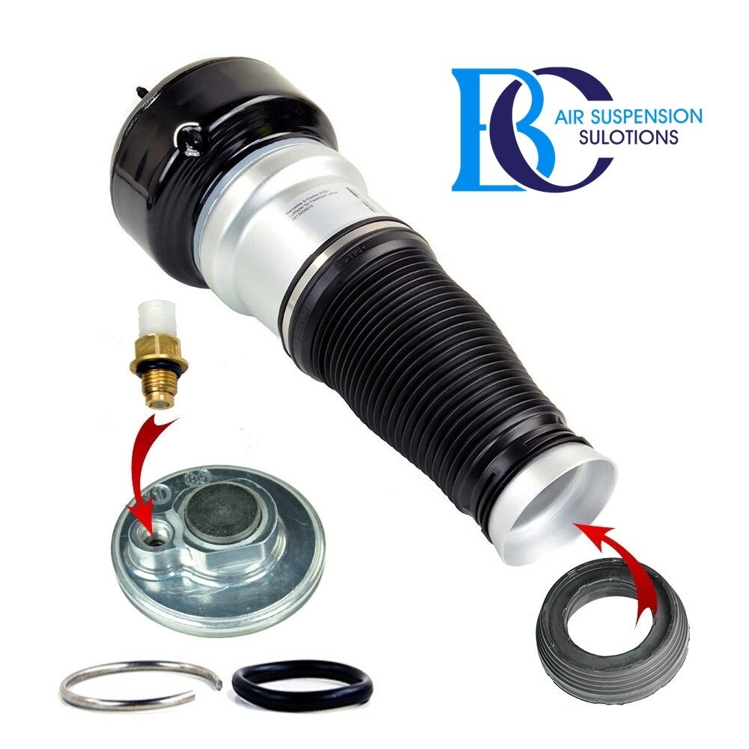

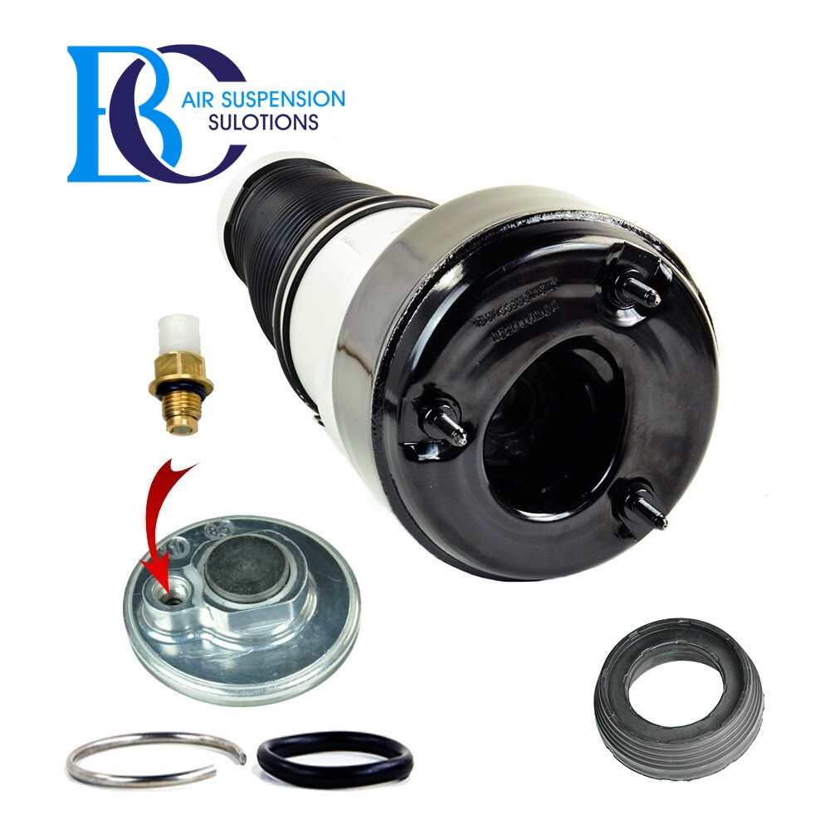Description

This is a new air spring for front side.  
 This is a repair kit for the complete suspension strut. This type of repair kit is not available as an original spare part.  
 This means that you would have to buy a complete strut. Repairing the strut makes sense only if the shock absorber still has a sufficient efficiency.  
 This repair kit should not be used for oil leaking shock absorbers.  
 .  
 If the air strut is broken, but the shock absorber still has the best properties, you can use this set to restore the function of the complete shock absorber.

**Original spare part numbers of the aie strut:**

A2213209313, 2213209313, A221320931389, 221320931389, A2213204913, 2213204913

Mercedes S C216 4Matic Air suspension struts AIRMATIC, Left Front

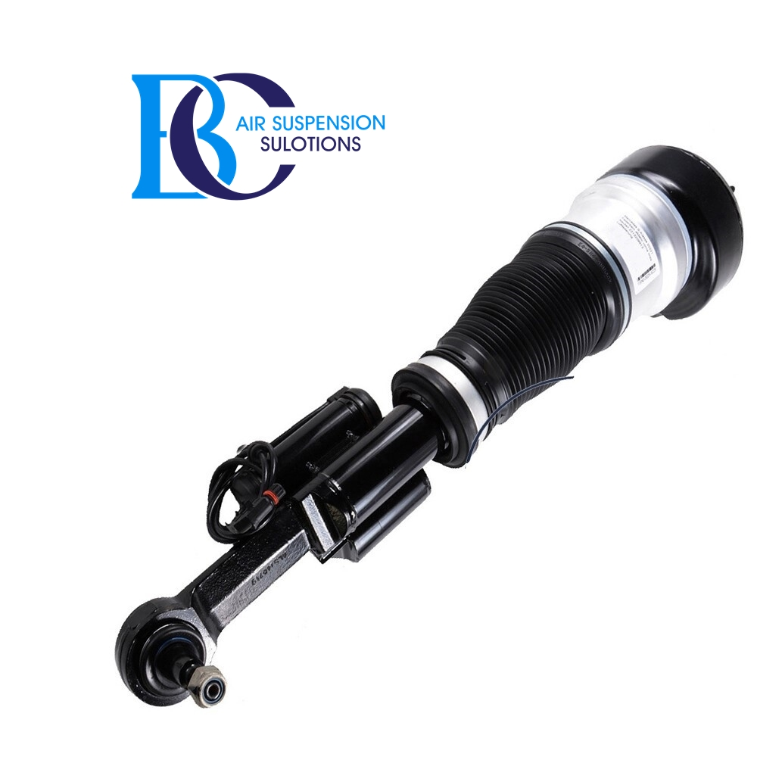

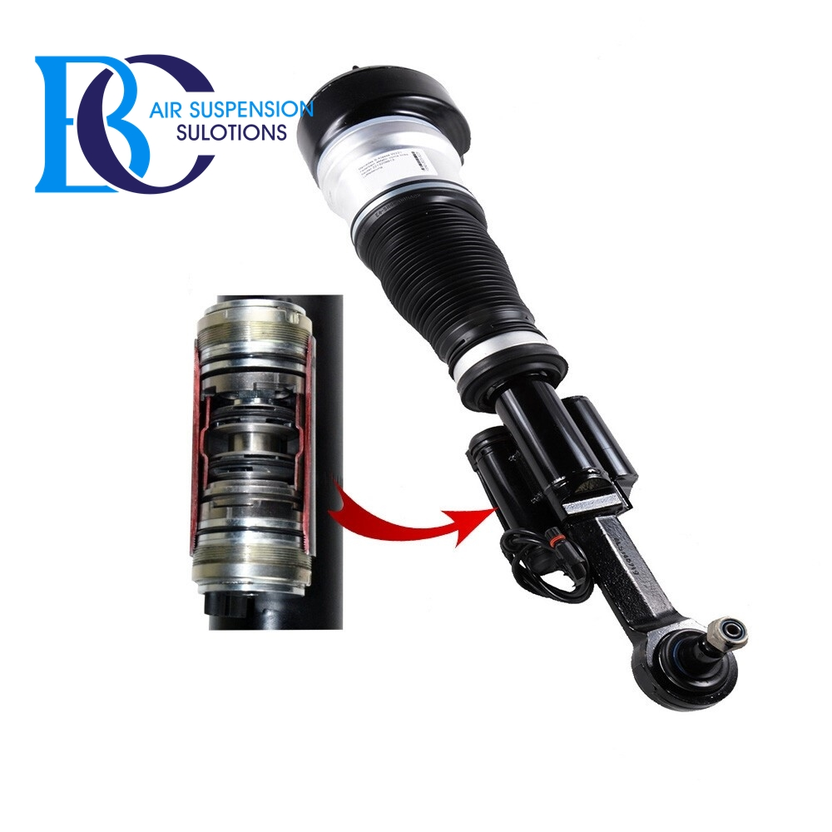[Description](https://www.miessler-automotive.com/Mercedes-S-C216-4Matic-Air-suspension-strut-AIRMATIC-FL#tab-description)

Front left air spring dampers with ADS adaptive damping system semi-active for the AIRMATIC Dual Control / air suspension exclusively for 4MATIC.

Due to the complex sensor system, the control unit changes the function of the hydraulic DampTronic shock absorber in dependence

-the road surface,

-the driving style,

and your chosen mode of driving dynamics system "Drive Select".

.

**Can be installed in the following vehicles:**

Mercedes-Benz CL-Class C216 4MATIC (2006-2013)

.

**Original spare part number:**

A2213201738, A221320173889, A2213200438, A221320043889, A221320173838, A221320173880, A221320043838, A221320043880

A2213205313, A221320531338, A221320531380, A22132053133880

2213201738, 221320173889, 2213200438, 221320043889, 221320173838, 221320173880, 221320043838, 221320043880

2213205313, 221320531338, 221320531380, 22132053133880

Mercedes S C216 4Matic Air suspension struts AIRMATIC, Right Front

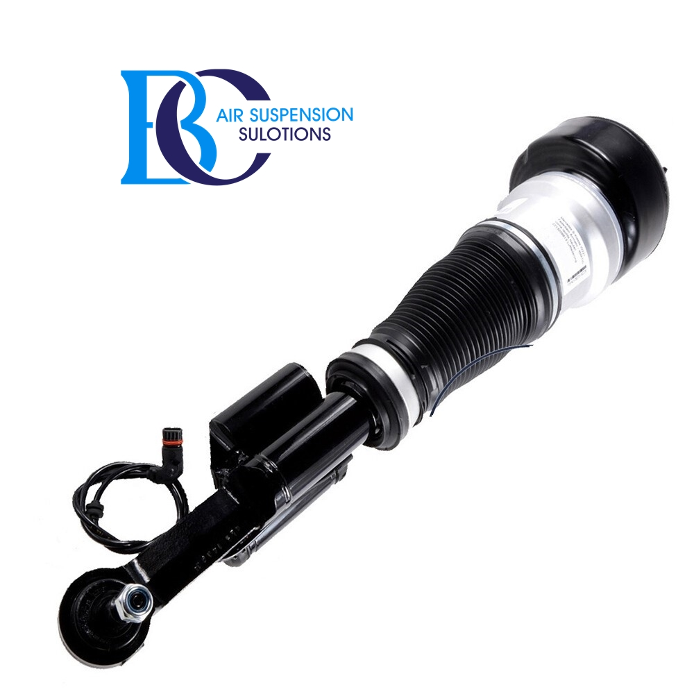

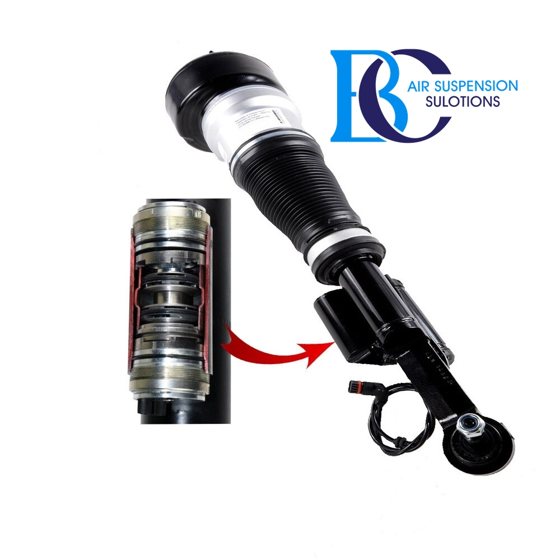 [Description](https://www.miessler-automotive.com/Mercedes-S-C216-4Matic-spring-strut-FR#tab-description)

Right front air spring dampers with ADS adaptive damping system semi-active for the AIRMATIC Dual Control / air suspension exclusively for 4MATIC.

Due to the complex sensor system, the control unit changes the function of the hydraulic DampTronic shock absorber in dependence

-the road surface,

-the driving style,

and your chosen mode of driving dynamics system "Drive Select".

.

**Can be installed in the following vehicles:**

Mercedes S-Class Coupe (C216) 2006-2013

CL 500 4-matic (216.386, 216.394) 2008/02-2013/12

.

**Original spare part number:**

A2213201838, A221320183889, A2213200538, A221320053889, A221320183838, A221320183880, A221320053838, A221320053880

A2213205413, A221320541338, A221320541380, A22132054133880

2213201838, 221320183889, 2213200538, 221320053889, 221320183838, 221320183880, 221320053838, 221320053880

2213205413, 221320541338, 221320541380, 22132054133880

# **Mercedes S C216 Air suspension strut AIRMATIC (Rear Left)**

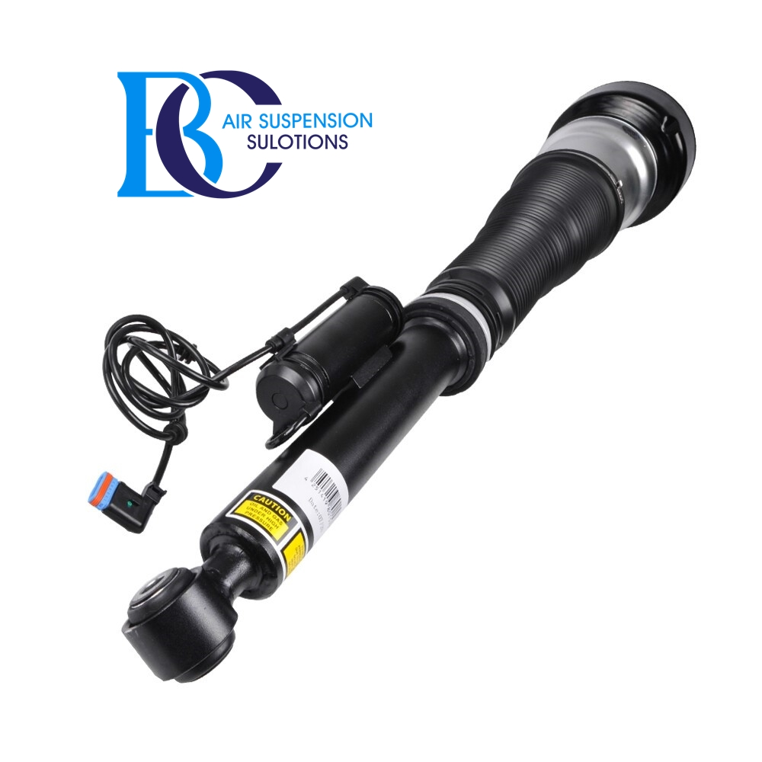

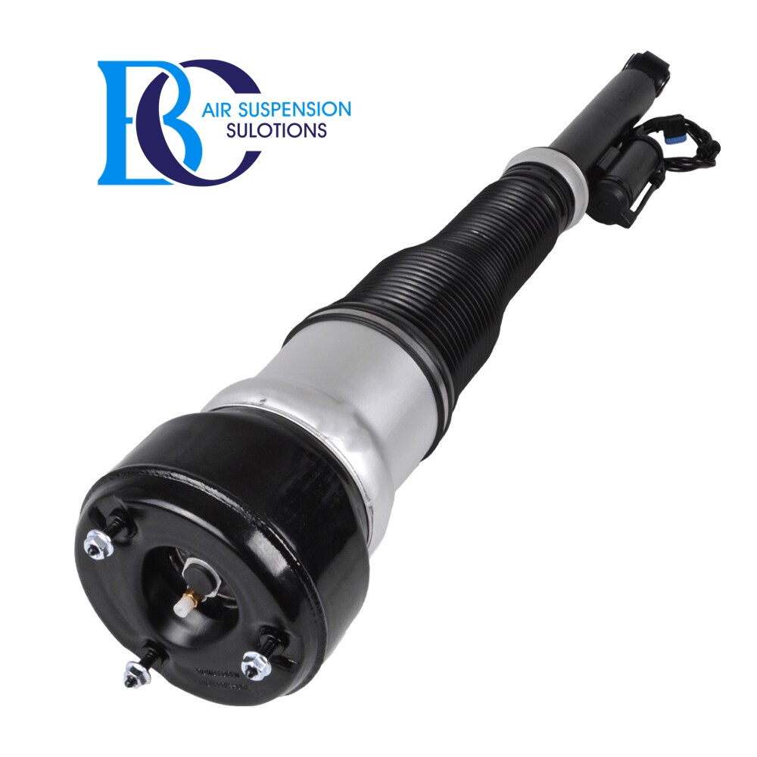

Description

This is a new shock absorber from Rear Left.

This shock absorber meets the same technical requirements as the original.

Active inner valve in the shock absorber.

This means that this shock absorber reacts actively to the driving comfort you choose.

You will receive an air suspension damper with ADS (Adaptive Damping System).

Fed by a complex sensor system, the control unit changes its mode of operation

-depending on the surface of the road,

-depending on the style of driving,

-depending on the mode of drive dynamics system "Drive Select".

.

**Can be installed in the following vehicles:**

Mercedes S-Class Coupe (C216) 2006-2013

CL 500 4-matic (216.386, 216.394) 2008/02-2013/12

.

**Original spare part number:**

A2213205513, 2213205513, A2213205713, 2213205713, A2213201338, 2213201338

A221320551380, 221320551380, A221320571380, 221320571380,

A221320551389, 221320551389, A221320571389, 221320571389

# **Mercedes S C216 Air suspension strut AIRMATIC (Rear Right)**



[Descripti](https://www.miessler-automotive.com/Mercedes-S-C216-Air-suspension-strut-AIRMATIC-RR#tab-description)on

This air strut with the original part number A2213205613 for the Mercedes-Benz S-Class C216 corresponds to the original series damper for the versions with ADS (Adaptive Damping System).

Due to the complex sensor system, the control unit changes the function of the hydraulic DampTronic shock absorber in dependence

-the road surface,

-the driving style,

and your chosen mode of driving dynamics system "Drive Select".

.

**Can be installed in the following vehicles:**

Mercedes S-Class Coupe (C216) 2006-2013

CL 500 4-matic (216.386, 216.394) 2008/02-2013/12

.

**Original spare part number:**

A2213205613, 2213205613, A2213205813, 2213205813, A2213201438, 2213201438

A221320561380, 221320561380, A221320581380, 221320581380,

A221320561389, 221320561389, A221320581389, 221320581389